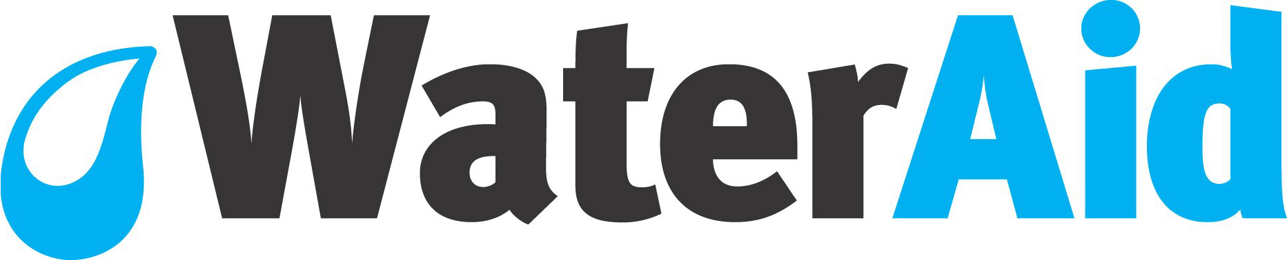

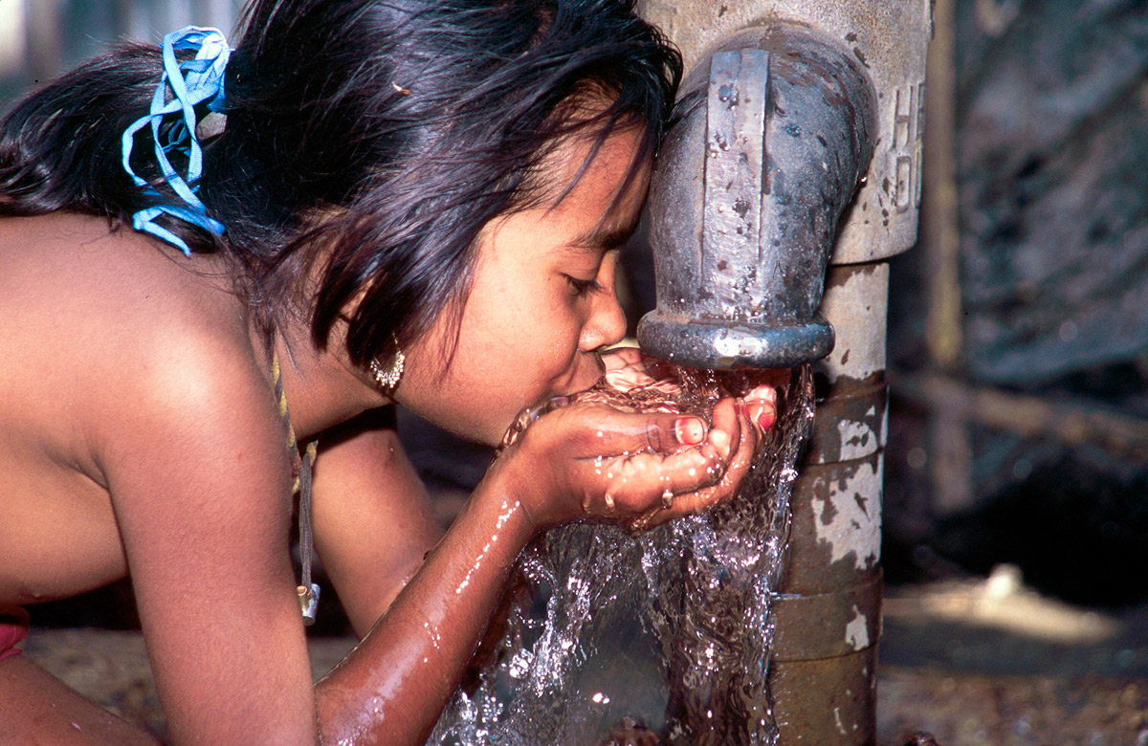

Programme Officer

 |  | 

Job Description

Job title: | Programme Officer
Place of work: | 47-49 Durham Street, London, SE11 5JD
Band: | D
Reports to: | Technical Support Manager – Sanitation & Hygiene
Manages: | Specific projects, project partners, consultants as required
Budget responsibility: | Delegated budget management responsibility in accordance with WaterAid policy
Travel: | Up to 8 weeks per year

Introduction
The Programme Officer will be based in the Programme Support Unit (PSU) which is part of the International Programmes Department in the UK. PSU provides programme quality support in three overlapping areas:

- Quality Programming: Drawing on evolving best practice from within WaterAid and across the sector, providing guidance, support and minimum standards.
- Research Learning and Documentation: Promoting learning and filling internal and sector knowledge gaps through supporting quality research design and implementation, coordinating multi-country research, identifying and supporting quality documentation and dissemination.
- Accountability & Effectiveness: Developing and supporting WaterAid’s global programme accountability and effectiveness processes and systems. Includes external evaluations, post-implementation monitoring, programme planning, monitoring and reporting systems.
The PSU works directly with the four WaterAid Regional Teams (West Africa, East Africa, Southern Africa and South Asia) as well as with staff from our Country Programmes. We also work very closely with the Policy and Campaigns Department and Communications and Fundraising departments, ensuring joined up approaches and messaging. Within the overall WaterAid International federation, the team liaises closely with other teams across the WaterAid members (Australia, America, Canada, Sweden and Japan), drawing on our global experience and expertise and providing cross member support as necessary.

This post will be located in the Quality Programming (QP) team and managed by the Technical Support Manager – Sanitation & Hygiene, but will also have other thematic responsibilities.

Job Purpose
To assist the Technical Support Managers and Programme Managers in the Quality Programming team, and in partnership with the Regional teams, deliver focused technical and programmatic design, development and implementation support to country programme teams. Under the guidance of their manager or other Technical Support Managers, it is expected that the incumbent will be required to directly develop and lead specific technical activities for about 25% of their time. The focus of these specific activities might change from time to time in accordance with the unit’s plans.

Key accountabilities
Quality Programming - general:
- Support and participate in support and/or assessment visits to country programmes designed to improve the design, development and implementation of programmes or projects.
- Provide direct input into the development of key organisational guidance or standards documentation.
- Support and participate in the roll-out processes of new frameworks, policies and guidelines. This includes the development of training materials and delivery of internal training courses or the facilitation of workshops.
- Provide direct support (e.g. answering standard technical queries, checking technical accuracy of communications or fundraising products) to non-technical departments and teams in WaterAid in their understanding of technical issues and in their fundraising, communications and influencing roles.
- Manage and co-moderate the implementation of KnowledgePoint as an internal and external question and answer online system / service.
- Work with the relevant staff in the People and Organisation Development department to develop, coordinate and maintain relationships with relevant institutions who may be able to offer chartership or membership opportunities for WaterAid programme staff. This includes the promotion of these opportunities as they develop.
- In coordination with other team members, develop and maintain external relationships to share best practice and develop collaborative work that supports this.
- As a member of other project and activity teams, providing timely technical and logistical support, as assigned from time to time.
- Contribute to the planning, budgeting and reporting tasks of PSU.

Quality Programming – specific expertise:
- Provide and coordinate advice, support, learning and documentation (to & with regional and country staff) on issues related to:
  - Faecal sludge management, particularly with respect to urban environments
  - WaterAid’s approaches to disaster risk reduction.
  - Entrepreneurial / small business approaches to sanitation and water service delivery.

Person specification
Essential
- Graduate degree in a relevant subject (development studies, health, engineering, social sciences) and significant international field experience
- Membership of a relevant professional body or organisation, preferably working toward Chartered status.
- Experience of working in the water and sanitation sector in the developing world and sound knowledge of a core of relevant issues and approaches, preferably in urban and small town settings.
- Experience in developing and facilitating effective training courses or workshops.
- Commitment to WaterAid’s values and a working style that reflects these.
- Computer literate (excellent Microsoft office skills, including Word, Outlook and Excel).
- Experience of managing projects, to budget and timescale
- Excellent communications skills including written and spoken English.
- Proven ability to manage multiple tasks, in a proactive and organised way
- Commitment to personal learning, development and improvement in pursuit of own objectives and those of the team and organisation.
- Ability and willingness to spend significant time travelling in Africa and Asia – up to 8 weeks per year.
- A self starter, able to work independently and drive tasks forward, escalating issues where appropriate.
- A team player, able to work in a collaborative way.

Desirable
- Postgraduate degree in a relevant subject (development studies, health, engineering, social sciences)
- Experience in working with international NGOs.
- Experience and detailed expertise in at least one of the specific areas of expertise required: faecal sludge management, disaster risk reduction and entrepreneurial or small business approaches.
- Experience in managing budgets and reporting progress against plans.
- Experience of managing consultants.
- Knowledge of databases, statistics software, and GIS.
- French and/or Portuguese language skills.

Abbreviated Terms & Conditions
Salary | Starting from £31,468 with excellent benefits
Location | WaterAid, 47 - 49 Durham Street, London, SE11 5JD
Right to Work | In order to apply for this role you must be able to demonstrate your eligibility to work in the UK
Travel | Up to 8 weeks per year
Working Hours | Full time - Standard working hours at WaterAid are 35 hours per week, Monday to Friday. Core office hours are between 10.00am and 4.00pm. Start and finish times are to be agreed with the line manager upon joining.
Annual Leave | 25 days per year plus all UK public holidays (pro rata). The number of annual leave days will increases to 27 days (pro rata) after four years’ service
Contract Period | The post is offered on a permanent contract
Probation | The appointment is subject to the satisfactory completion of a six month probationary period
UK Benefits | Group Personal Pension Scheme with following contribution rates:  There is an option for pension contributions to be made through a salary sacrifice arrangement
  Employee’s Contribution | Employer’s Contribution
  3% | 6%
  4% | 8%
  5% | 10%
UK Benefits | Life Assurance scheme equating to 4 x basic annual salary
UK Benefits | Interest free season ticket loan, available on completion of probation
UK Benefits | Employee Assistance Programme with access to 24 hour free and confidential helpline
UK Benefits | Child care voucher scheme
UK Benefits | Cycle to work schemes
UK Benefits | Medical benefits (either through medical insurance or reimbursements system)

Recruitment process

Closing date: 4 November 2013

Interviews: First interview: 2 December 2013
Second interview: 9 December 2013

Please apply using our online application form at: https://jobapplication.wateraid.org.

WaterAid is committed to welcoming people from the widest possible diversity of backgrounds, culture and experience, and is signed up to the ‘Positive About Disabled People’ scheme. We will make any practical, reasonable adjustment to enable disabled people to participate fully in an inclusive working environment.

We are committed to interviewing all disabled applicants who meet the minimum criteria for a job vacancy and to consider them on their abilities.

Please let us know if you are disabled and need any assistance in making your application or you have any special requirements should you be selected for interview.

Your application must be in English.

If you are unable to apply online, you may post your application to the People Team, WaterAid, 47-49 Durham Street, London SE11 5JD, UK or fax it to +44 20 7793 4994 under confidential cover by the closing date.

Only shortlisted candidates will be contacted. Please assume that you have not been shortlisted if you have not heard from us within 2 weeks of the closing date.

